**Colour by Multiplication**

Do the multiplication calculation and colour the shape in the correct colour.

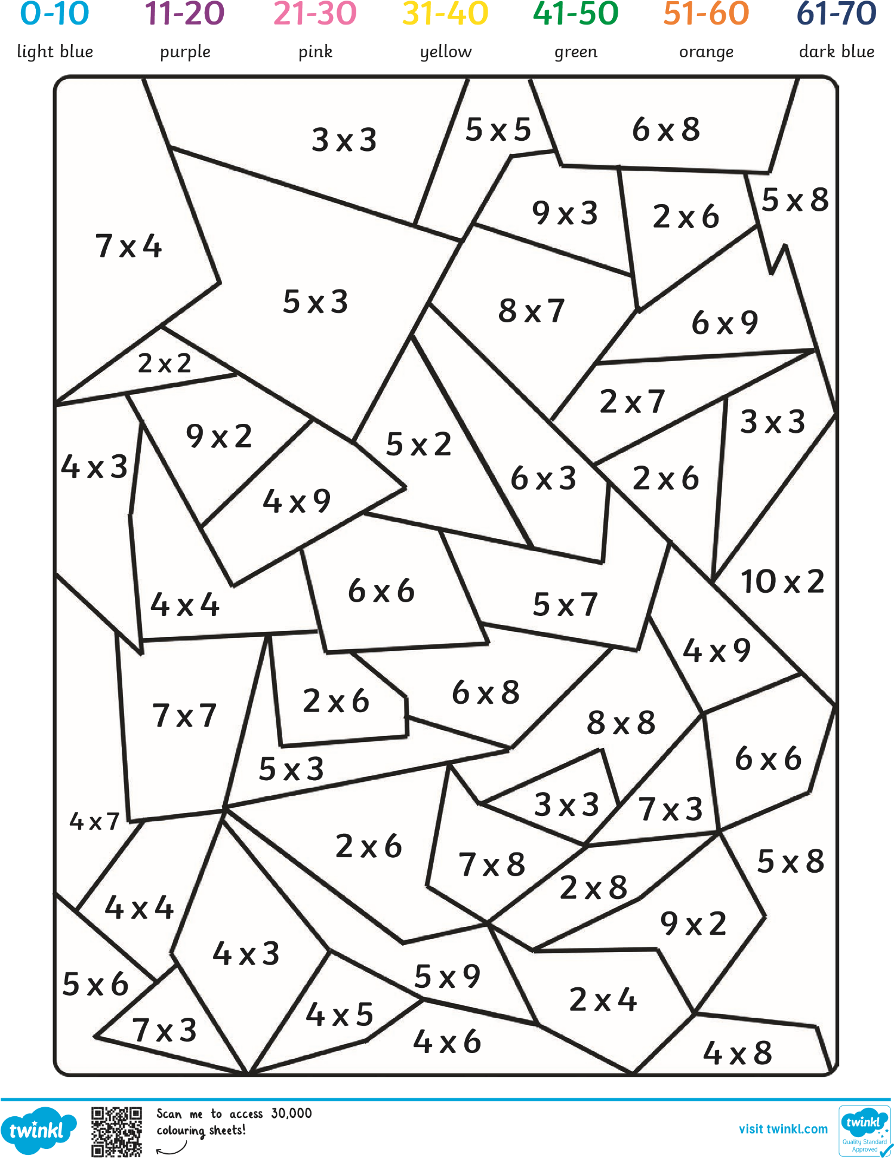

Tomado y adaptado por English adventure

# Colour by Multiplication **Answers**

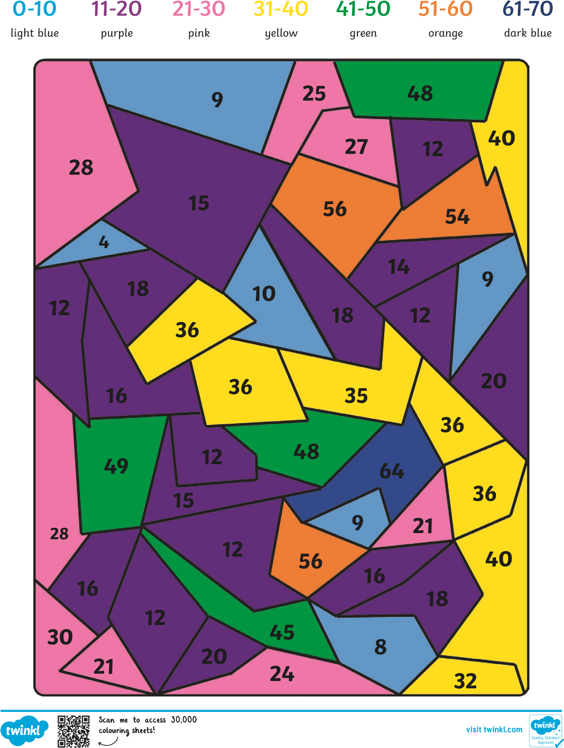

Tomado y adaptado por English adventure